PA_2_Classfication[NN]

* Explain all the preprocessing done in detail. [4 points]
* As you can clearly see we have few null values in ‘bmi’ column, in-order to prevent data loss by deleting records I rather choose to calculate mean value for ‘bmi’ col by grouping up by age columns which seems sensible thing to do. This will result in giving up mean value for that empty field after grouping up age column

So, it will only place mean value by calculating mean of other ppl whose age is 61.

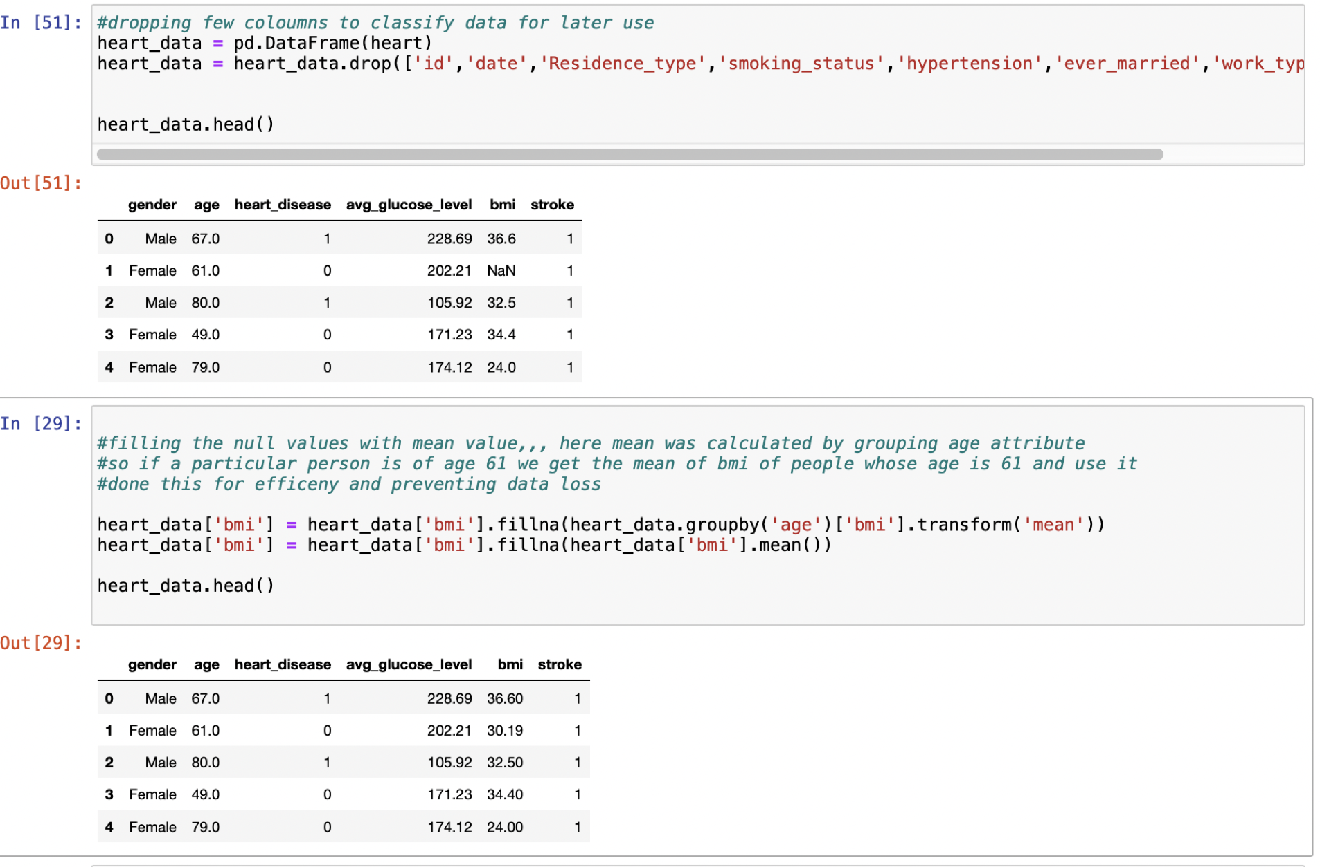

* Code/algo might not react as it is expected to be if features don’t look like standard data, if we found more zeros, the variance will be at extreme end, into order to reduce the dominance on the data by single feature we scale it

we did fit into data frame and transformed it to scale

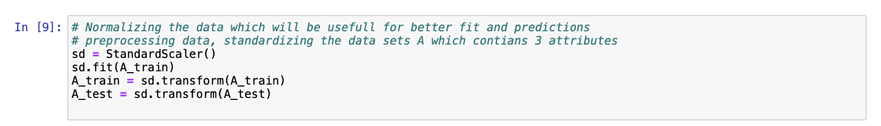

2) Explain all the parameters of KNN in details in your own words. Do not copy paste. Give references. 10 Points will be deducted if you copy paste from the internet. [5 points]

KNN is very simple algorithm, they are various parameters which we can use as per our requirement don’t have to build a model.

n_neighbors : - it is a user defined constant, it’s just kth node will be our neighbor and the object will be assigned to that particular node when in clustering by using knn when its value is k.

p : - this parameter guides us our algorithm which distance method to be used. if p = 1 : knn uses Manhattan distance, if p = 2 : knn uses Euclidean distance, if p =! 1 or p=!2 (other than 1 and 2) : knn uses Minkowski distance

metric: - gives the distance metric to use it for the tree for the ways it acts with the data to few operations as searching and all other tree operations its has its own distance functions like Manhattan, Euclidean Minkowski, Chebyshev etc.,

leaf_size: it might help you to adjust the speed of execution of query or any operation performed using knn or the storage aspects / memory of the code , ultimately every dataset needs to have different size, depends entirely on the type of data we get

n_jobs : haven’t really used it, but it gives out how many parallel operations you can run at one time.

3) Explain what was your criteria for selecting the three attributes. [5 points]

To select features that have strongest relationship with the output variable statistical tests are used.

As output variable is stroke – I fell they are few factors why people get stroke

Had to cutoff few variables and stay with few like gender , age, heart-condition,etc.,

The scikit-learn library provides the [Select Best](http://scikit-learn.org/stable/modules/generated/sklearn.feature_selection.SelectKBest.html#sklearn.feature_selection.SelectKBest) class that can be used with different statistical tests to select a specific number of features.

SelectKBest (score_func=chi2, k=3)

Here score function is chi-squared (chi²) and k is number of features.

age, bmi and avg_glucose_level were the top features from the selectkbest

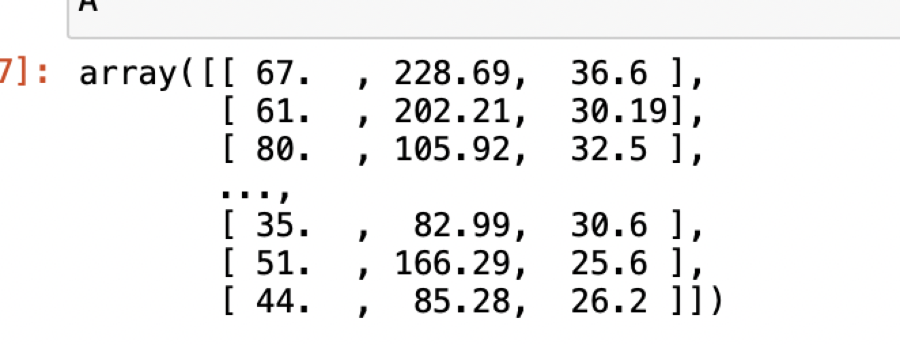

4) Visualizations of the classifier in a 2D projection and write your observations. [4 points]

For k = 1

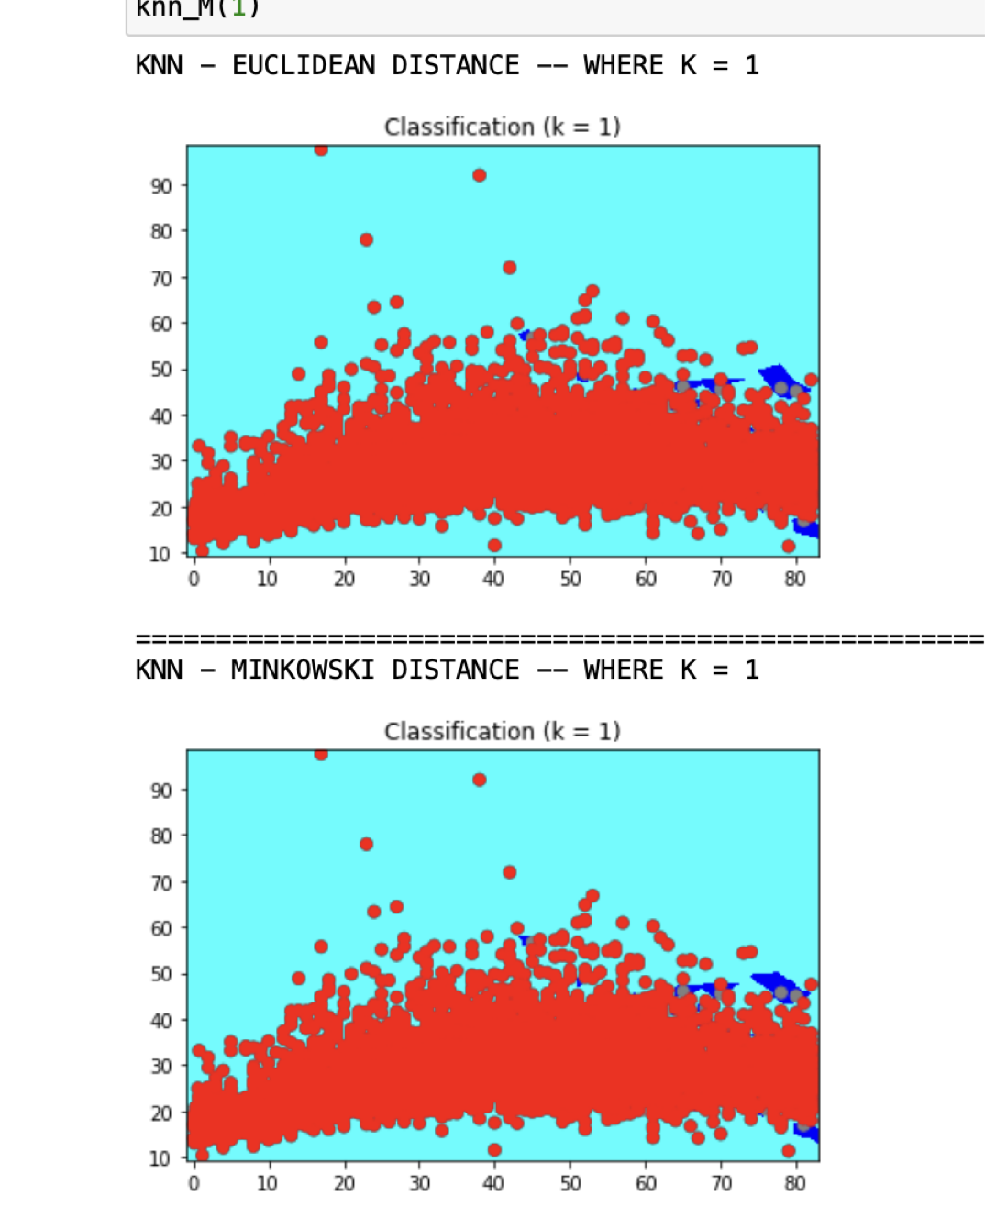

For k = 5

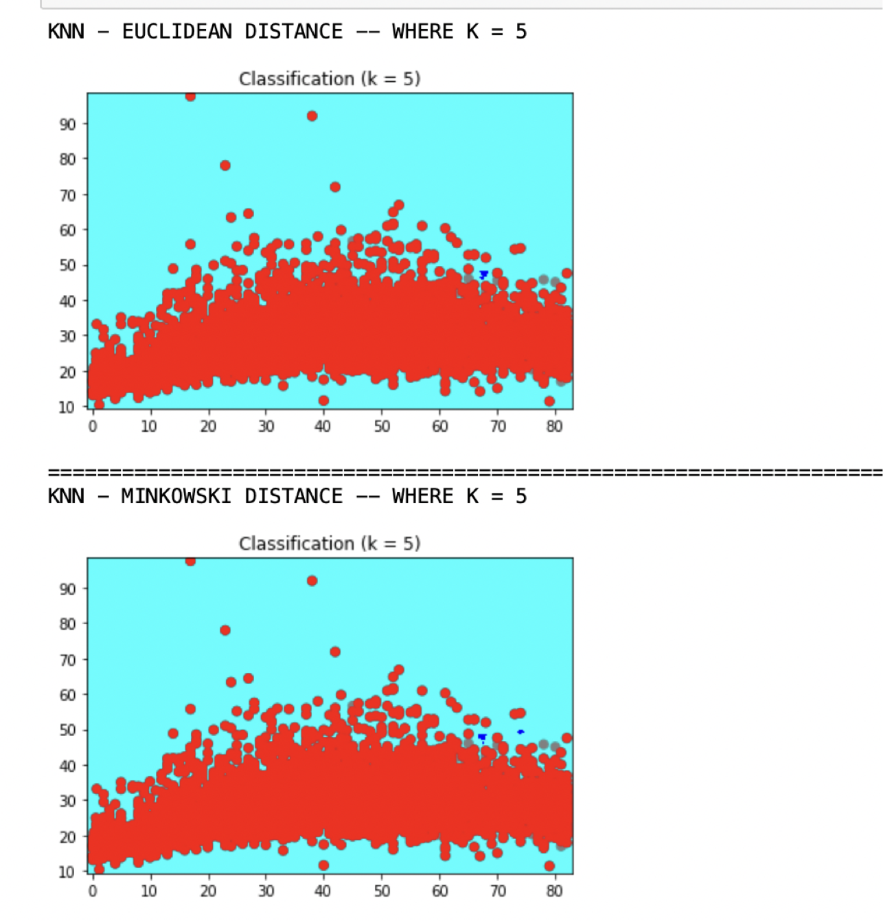

For k = 10

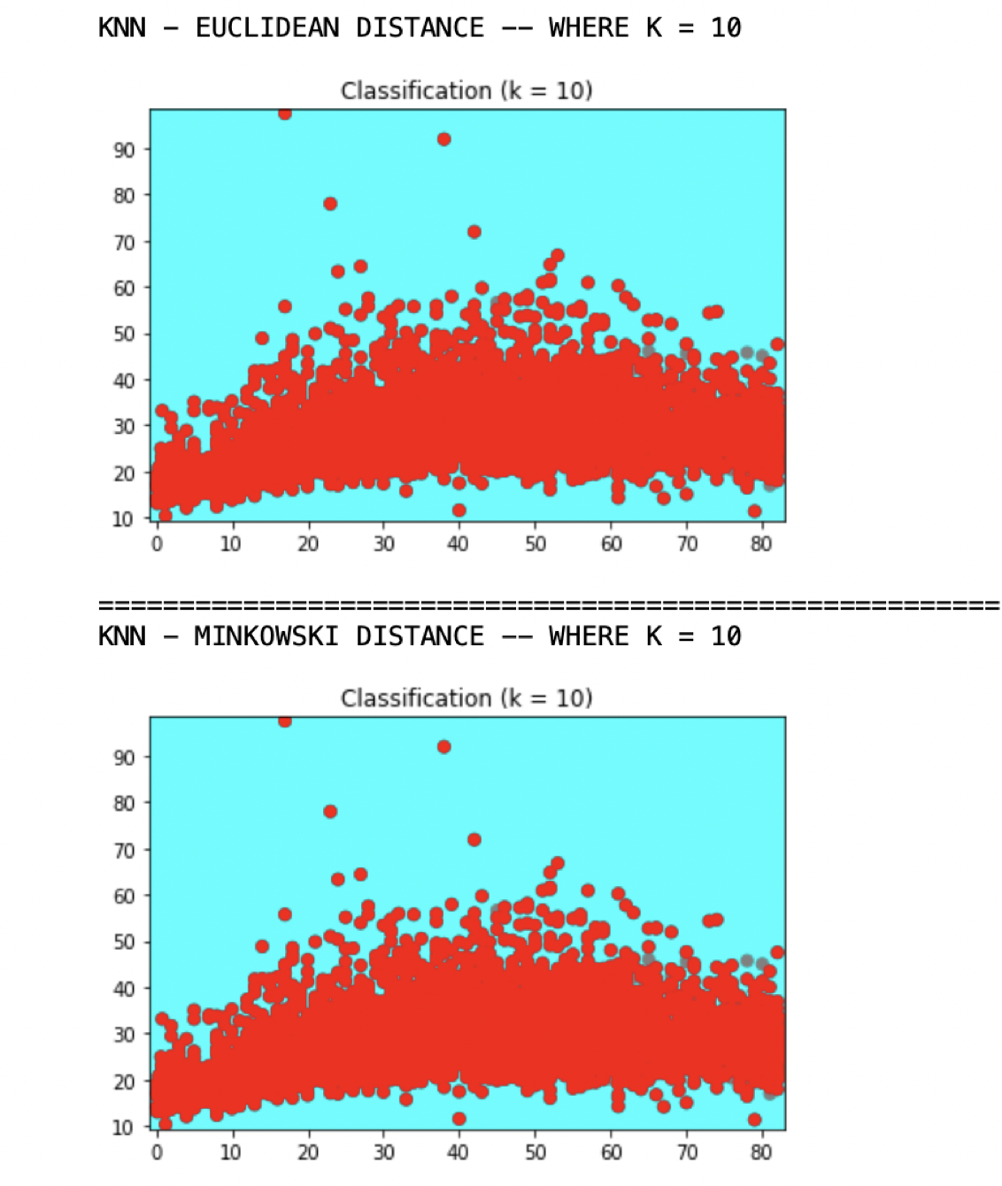

We have taken age on X axis, and bmi on Y axis. Scatter gives out ‘plots for feautres’. The 2 colors in background mesh represent 2 different targets. The 3 figures represent visualization when k-value is 1, 5, 10

As data inputs are much higher, we could not see the major change clustering but see they are slight changes if we look out closer at the plot, we change the nearest neighbors to 10 from 1 as k =10 gives out no stroke value and see much more clustering in Euclidean and Minkowski and at k=5 not so much classified. For both Euclidean

1. Interprete and compare the results explain in details.[5 points]

We have created a model with three different randomly chosen k values (1, 5, 10) and displayed the accuracy for those three different k values. **Training accuracy** rises as model complexity increases. The following tables and graphs show us the relation between knn and accuracy, knn and error rates. To choose an optimal k you must plot a graph between error rates and k values for the unseen data that is the test data. We have taken 30 different k-values and calculated their error rates. The error rate is high when k value is high. In our graph k = 10 gives us high accuracy and low error rate, when algorithm on Euclidean distance. But for knn when it uses Minkowski, we found out the at k =12 it has best optimal and error rates is also low. Please find the below images

For Euclidean

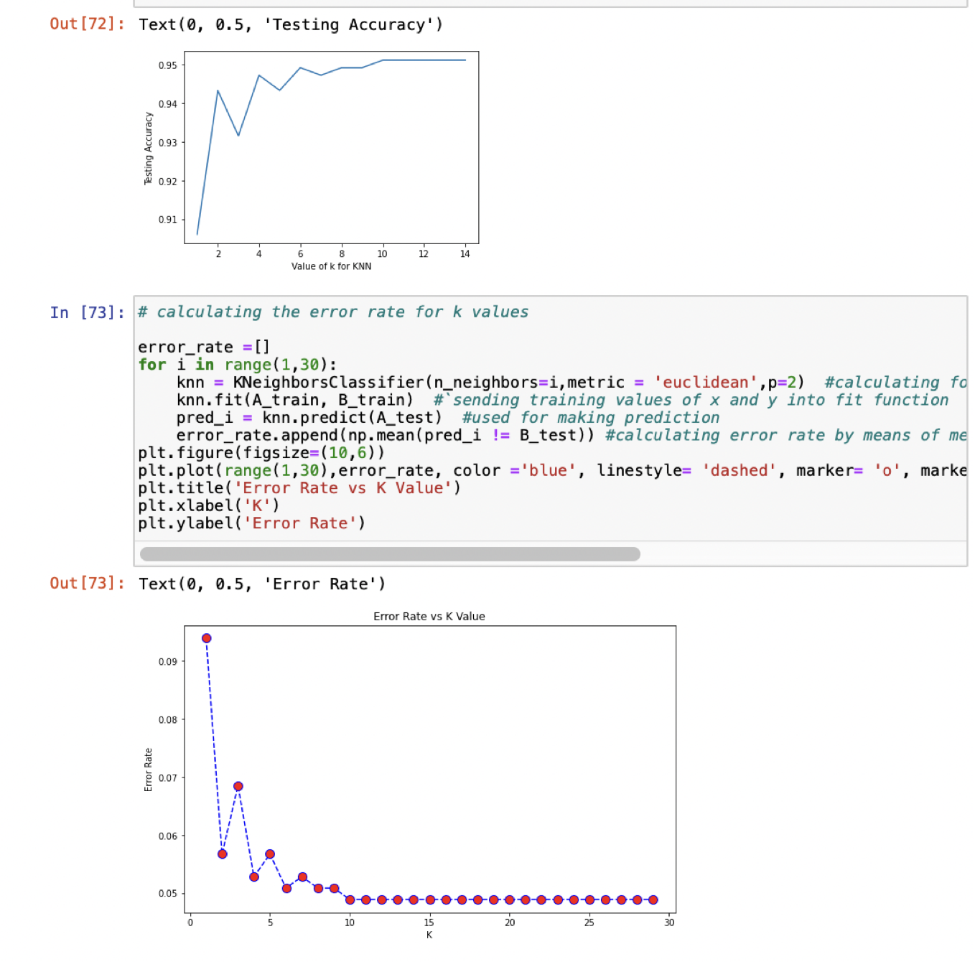

For Minkowski

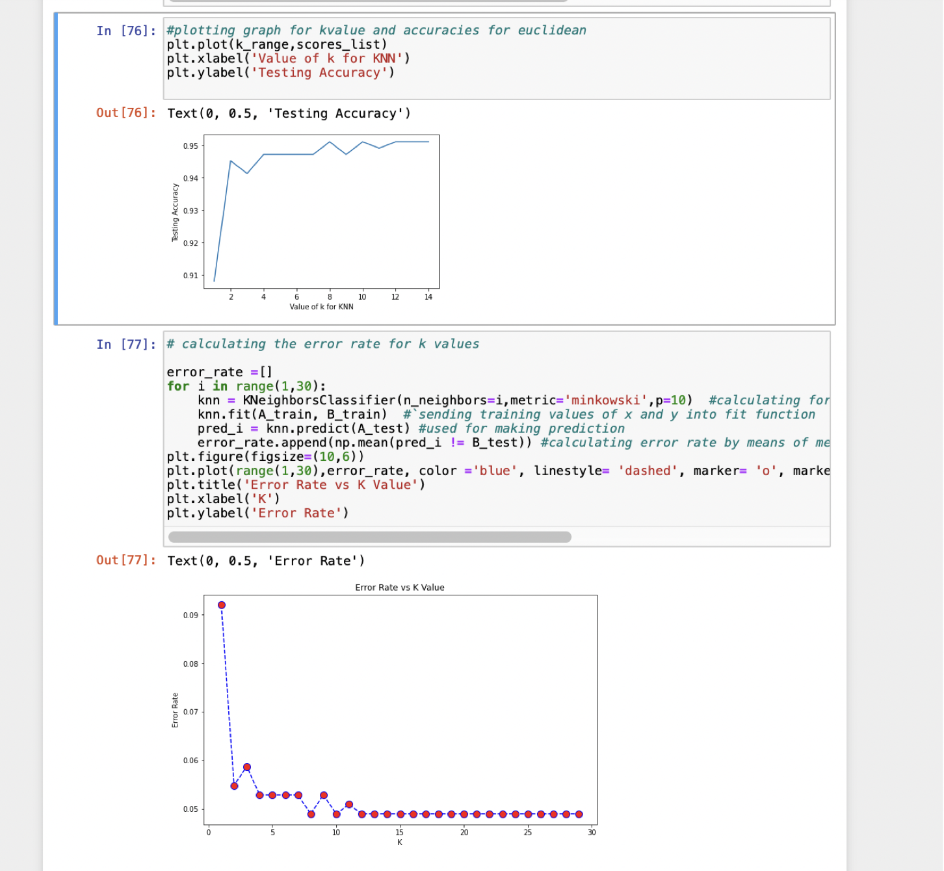

# REFERENCES

<https://towardsdatascience.com/building-a-k-nearest-neighbors-k-nn-model-with-scikit-learn-51209555453a>

<https://www.kaggle.com/lalitharajesh/iris-dataset-exploratory-data-analysis>

<https://medium.com/@seocodingvidya/python-how-to-draw-confusion-matrix-using-matplotlib-61cd891a3c7f>